FIFO Page Replacement

HARIRAJ G

230701104

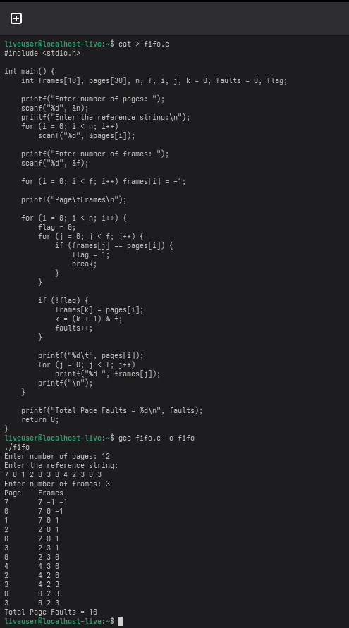

LRU Page Replacement

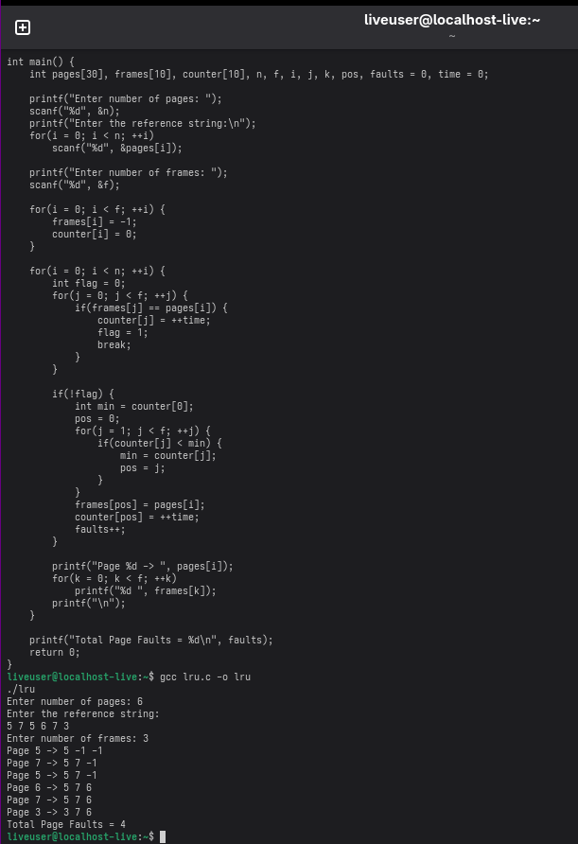

Optimal Page Replacement

